GUI component list

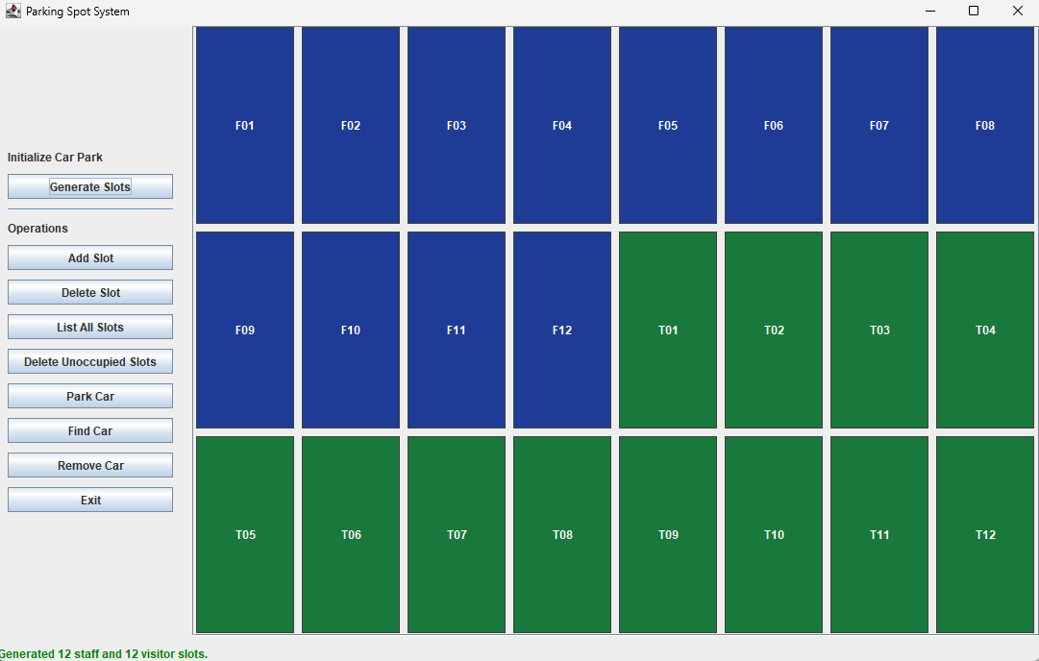

The GUI is separated into 3 parts: the event buttons, the parking slot interface, and the event notification

# Event buttons:

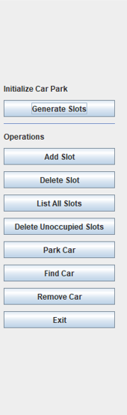

## Generate Slots:

When selected, the user is prompted with the number of the staff and visitor parking slots.

## Add Slot:

When selected, the user is prompted with the ID of the added slot with its type (staff or visitor)

## Delete Slot:

When selected, the user is prompted with the ID of the slot that he/she wants to delete

## List All Slots:

When selected, this will show a table with all of the slots with its parked car (if parked) also with all of its details

## Delete Unoccupied Slots:

When selected, this deletes all parking slots not occupied by a car

## Park Car:

When selected, the user is prompted with: the parking slot ID, the car registration number, the owner’s name, and a checkbox if this car is a staff car (it will be a visitor car if not checked)

## Find Car:

When selected, the user is prompted with the ID of the car that he/she wants to find

## Remove Car:

When selected, the user is prompted with the ID of the car that he/she wants to remove

## Exit:

This exits the program

# Parking slot interface:

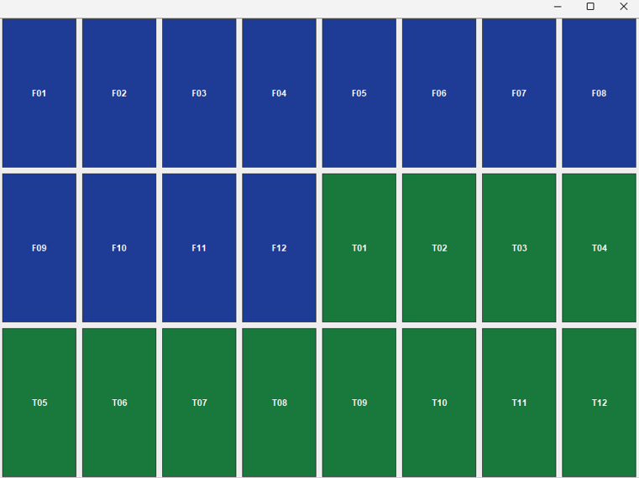

The generated parking slots are displayed here. The color indicates the type of parking slot. If a slot is occupied, there will be a yellow border

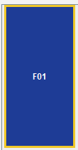

The user can hover over a slot to see the tooltip information of that slot

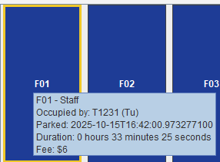

* User can left-click on a slot to park or remove a car
* User can right-click on a slot to delete the slot (occupied slot cannot be deleted)

# Event notification



This display the latest notification of the user’s action